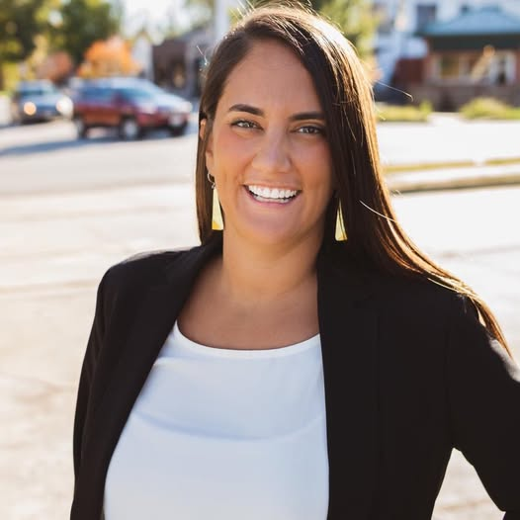

Betsy Fogle
October 7, 2025

Table of Contents
Top Hits 5
Social Media 9
Political Spending 9
Federal 9
State 9
Background 10
Education 10
Career 10
Education 11
Missouri National Education Association 11
Missouri State Teachers Association 11
Scholarship Program 12
School Choice 13
Parental Bill Of Rights 14
Voting 15
LGBTQ 16
Transgender 16
Taxes 20
Criminal Justice 22
Defunding The Police 22
Racial Issues 24
DEI 24
Healthcare 25
Medicaid Expansion 25
Other Issues 27
2nd Amendment 27
Abortion 27
Religion 28
COVID 28
Court Packing 29
Environment 29
Free Speech 29
Medicare For All 29
Border 29
Media Bias 30

Top Hits
Education

Fogle Is Backed By The Teachers Unions
Fogle Was Endorsed By The Missouri National Education Association. (Missouri National Education Association, “Missouri NEA Political Action Committee Makes Recommendations for General Election,” Press Release, 9/24/20)
- Fogle Posted An NEA Endorsement Alert On Her Instagram. (Betsy Fogle Instagram, 7/15/20)
Fogle Received $500 From The Missouri National Education Association. (Followthemoney.org, Accessed 9/24/25)
Fogle Has Received 2 Contributions Totaling $1,000.00 From The Missouri State Teachers Association. (Followthemoney.org, Accessed 9/24/25)

Fogle Has Voted Repeatedly Against School Choice And Charter Schools
Fogle Voted Against A Bill Providing Scholarships For Students To Attend Private Schools. (Kaitlyn Schumacher, “Missouri's House passes proposal to provide scholarships to private schools,” KYTV, 3/2/21)
In 2021, Fogle Voted Against HB 349, Expanding School Choice Through The Creation Of The Missouri Empowerment Scholarship Account Program. (HB 349, Passed 82-71, 2/25/21, Fogle Voted No)
In 2021, Fogle Voted Against HB 137, Ensuring Funding Equality For Charter Schools. (HB 137, Passed 86-66, 4/15/21, Fogle Voted No)
In 2021, Fogle Voted Against SB 86, Prohibiting School Districts From Engaging In Political Electioneering And Expanding School Choice. (SB 86, Passed 84-67, 5/11/21, Fogle Voted No)
In 2021, Fogle Voted Against HB 2, Attacking School Choice By Cutting Charter School Funding. (HB 2, Failed 47-104, 3/30/21, Fogle Voted Yea)
In 2022, Fogle Voted Against HB 1552 Which Amends The State Charter School Funding Formula. (HB 1552, Passed 103-48, 3/9/22, Fogle Voted No)
In 2023, Fogle Voted Against HB 253 Which Establishes A State School Choice Voucher Program. (HB 253, Passed 85-69, 3/8/23, Fogle Voted No)
In 2024, Fogle Voted Against SB 727 Which Expands The Missouri Empowerment Scholarships Accounts Program. (SB 727, Passed 82-69, 4/18/24, Fogle Voted No)
In 2025, Fogle Voted Against HB 711 Which Establishes Open Enrollment Policies For Missouri Schools. (HB 711, Passed 88-69, 3/12/15, Fogle Voted No)

Fogle Has Voted Against Empowering Parents To Know What Their Kids Are Being Taught In Schools
In 2022, Fogle Voted Against HB 1858, Parental Bill Of Rights. (HB 1858, Passed 85-59, 4/19/22, Fogle Voted No)
In 2022, Fogle Voted Against HJR 110, Parents Bill Of Rights. (HJR 110, Failed 60-81, 5/9/22, Fogle Voted No)

Elections

Fogle Has Voted Numerous Times Against Securing Elections
In 2021, Fogle Voted Against HB 334 Which Requires Photo ID To Cast A Ballot. (HB 334, Passed 109-46, 2/24/21, Fogle Voted No)
In 2021, Fogle Voted Against HB 738 Which Establishes New Voter ID Laws. (HB 738, Passed 109-48, 3/25/21, Fogle Voted No)
In 2022, Fogle Voted Against HJR 131, Protecting Elections From Non-Citizens. (HJR 131, Passed 97-45, 4/6/22, Fogle Voted No)
In 2022, Fogle Voted Against HB 1878 Which Authorizes Secretary Of State To Audit List Of Registered Voters. (HB 1878, Passed 97-46, 3/10/22, Fogle Voted No)
In 2022, Fogle Voted Against HJR 94, Requiring An ID To Vote. (HJR 94, Passed 97-36, 3/10/22, Fogle Voted No)
Transgender Issues

Fogle Has Voted Numerous Times Against Protecting Kids And Girls Sports
In 2021, Fogle Posted A Photo Of Herself Holding A Sign Saying “Trans Kids Belong” On Instagram. “We are honored to stand with PROMO, ACLU of Missouri and all of the kids and families here in the Capitol today to speak out against #hjr53. Trans kids belong. Period.” (Betsy Fogle Facebook, 3/3/21)
Fogle Said A Statewide Constitutional Amendment On Banning Transgender Kids From Playing Sports With The Opposite Sex Could “Harm Transgender Children.” (Maria Benevento, “Missouri push to bar trans kids from playing sports on teams that match their gender criticized,” St. Louis Post-Dispatch, 3/4/21)
In 2021, Fogle Posted An Infographic On Instagram Saying “All Students Should Be Able To Participate In The Sports They Love” And Say She Wants To Stop Lawmakers From Keeping Transgender Youth From Participating With The Opposite Sex. (Betsy Fogle Facebook, 3/1/21)
In 2021, Fogle Voted Against HB 1141, Protecting Women’s Athletics From Competition With Men. (HB 1141, Passed 100-51, 4/21/21, Fogle Voted No)
In 2022, Fogle Voted Against HB 1973 Which Prohibits Transgender Girls From Playing On Female Sports Teams. (HB 1973, Passed 98-46, 4/28/22, Fogle Voted No)
In 2023, Fogle Voted Against HB 183 Which Prohibits Transgender Girls From Playing On Female Sports Teams. (HB 183, Passed 104-43, 4/17/23, Fogle Voted No)
In 2023, Fogle Voted Against SB 39 Which Requires Transgender Student Athletes Play Against Those Of Their Biological Sex. (SB 39, Passed 110-49, 5/10/23, Fogle Voted No)
In 2023, Fogle Voted Against SB 49 Which Prohibits Gender-Affirming Medical Care For Minors. (SB 49, Passed 108-50, 5/10/23, Fogle Voted No)
Taxes

Fogle Has Voted For Tax Hikes And Against Decreases
In 2020, Fogle’s Denied She Would Pass Tax Hikes And Defund The Police. (Austin Huguelet, “GOP attack ads flow into east Springfield House race,” Springfield News-Leader, 10/30/20)
In 2021, Fogle Voted Against HB 554, Reducing The Income Tax Rate And Removing Carve Outs To Select Retailers. (HB 544, Passed 96-59, 3/11/21, Fogle Voted No)
In 2021, Fogle Voted For SB 262, Increasing The State Gas Tax By 75%. (SB 262, Passed 104-52, 5/11/21, Fogle Voted Yea)
- In 2021, Fogle Voted Against SB 262, Requiring Voter Approval To Enact A Proposed Gas Tax Hike. (SB 262, Failed 48-102, 5/11/21, Fogle Voted No)
In 2023, Fogle Voted Against SB 190 Which Authorizes Counties To Repeal The Property Tax Rates Of Missouri Seniors 65 And Older. (SB 190, Passed 110-45, 5/8/23, Fogle Voted No)
In 2025, Fogle Voted Against HB 903 Which Reduces Personal Property Tax To 18% Of Market Value Over A 3-Year Period. (HB 903, Passed 84-63, 3/13/25, Fogle Voted No)
Criminal Justice

Fogle Has Called The Justice System “Racist”
Fogle Said There Is “Inherent Racism Within Our Criminal Justice System.” (Austin Huguelet, “Fogle, Helms duel in 135th; Dem. candidate confident she can unseat GOP incumbent,” Springfield News-Leader, 9/17/20)

Fogle Said She Wouldn’t Vote To Defund The Police But Has Voted Against Bills Trying To Prevent It
Fogle’s Denied She Would Pass Tax Hikes And Defund The Police. (Austin Huguelet, “GOP attack ads flow into east Springfield House race,” Springfield News-Leader, 10/30/20)
Fogle Voted Against SB 26, Combatting Efforts To “Defund The Police” And Protecting The Due Process Rights Of Law Enforcement Officers. (SB 26, Passed 108-47, 5/14/21, Fogle Voted No)
Fogle Voted Against SB 26, Combatting Efforts To “Defund The Police” And Protecting The Due Process Rights Of Law Enforcement Officers. (SB 26, Passed 108-47, 5/14/21, Fogle Voted No)
Fogle Voted Against SJR 38, Preventing Kansas City From Defunding The Police. (SJR 38, Passed 103-44, 5/13/22, Fogle Voted No)
Other

Fogle Supports DEI Initiatives
Fogle Said That “There Are A Lot Of Us” That Celebrate DEI Policies. (Maryam Khanum, “Missouri Attorney General Sues Starbucks for DEI Policy, Claims It Raises Prices and Slows Service,” Latin Times, 2/16/25)
Fogle Voted Against HB 742 Which Prohibits State Departments From Spending Money On Diversity, Equity, And Inclusion Initiatives. (HB 742, Passed 108-5, 2/20/25, Fogle Voted No)

Fogle Has Voted Against Religious Freedom
In 2022, Fogle Voted Against HB 1724, Religious Freedom On Campus. (HB 1724, Passed 95-36, 3/10/22, Fogle Voted No)
In 2023, Fogle Voted Against SB 34 Which Authorizes Schools To Offer Elective Courses On The Bible. (SB 34, Passed 99-45, 5/12/23, Fogle Voted No)
In 2024, Fogle Voted Against HB 1518 Which Prohibits Higher Education Institutions From Discriminating Against Religious Student Associations. (HB1518, Passed 100-46, 3/7/24, Fogle Voted No)
In 2025, Fogle Voted Against HB 75 Which Prohibits Any Public Official From Restricting Access To Places Of Worship. (HB 75, Passed 106-38, 2/13/25, Fogle Voted No)

Fogle Supports Packing The Supreme Court Of The United States
Fogle Voted Against SCR 6 Which Establishes Disapproval Of SCOTUS Expansion. (SCR 6, Passed 103-30, 5/13/21, Fogle Voted No)

Social Media
Personal Private Instagram
Campaign Instagram
Personal Private X
Campaign X
Campaign Facebook
Personal Facebook

Political Spending

Federal
In 2020, Fogle Contributed $50.00 To The Missouri Democratic State Committee. (Fec.gov, Accessed 9/24/25)
In 2024, Fogle Contributed $875.00 To The Missouri Democratic State Committee. (Fec.gov, Accessed 9/24/25)
In 2024, Fogle Contributed $47.35 To The Harris Victory Fund. (Fec.gov, Accessed 9/24/25)

State
In 2020, Fogle Contributed $19 To Cindy Slimp. (Followthemoney.org, Accessed 9/24/25)
In 2024, Fogle Contributed $88 To Crystal Quade. (Followthemoney.org, Accessed 9/24/25)
In 2024, Fogle Contributed $50 To Stephen Webber. (Followthemoney.org, Accessed 9/24/25)

Background

Education
Fogle Received A Bachelor’s Degree From Missouri State University And A Master’s Degree From The University Of Arkansas. “Born in Springfield, Fogle graduated from Springfield Public Schools. She obtained a bachelor’s of science degree from Missouri State University and a master’s in sociology from the University of Arkansas.” (Missouri House of Representatives, Accessed 10/2/25)

Career
Fogle Worked As A Director Of Program Advancement At Jordan Valley Community Health Center. “Fogle previously worked as director of program advancement at Jordan Valley Community Health Center and has been with United Way since 2023 as the AFL-CIO community service labor liaison. She says she considers herself a Springfieldian first and a Democrat second, and that guides how she works in Jefferson City.” (“In competitive Springfield district, Fogle and Hasty both want to do right by constituents,” Springfield News-Leader, 10/26/24)
Fogle Works As The AFL-CIO Community Service Labor Liaison For United Way. “Fogle previously worked as director of program advancement at Jordan Valley Community Health Center and has been with United Way since 2023 as the AFL-CIO community service labor liaison. She says she considers herself a Springfieldian first and a Democrat second, and that guides how she works in Jefferson City.” (“In competitive Springfield district, Fogle and Hasty both want to do right by constituents,” Springfield News-Leader, 10/26/24)

Education

Missouri National Education Association
In Her 2020 Election, Fogle Was Endorsed By The Missouri National Education Association. “Missouri NEA abides by a recommendation process that evaluates candidates based on their values, not party affiliation. Recommended candidates whose values closely align with MNEA's beliefs and legislative platform, which include protecting the rights of students and education employees; ensuring every student has a qualified, caring teacher; and investing in public education so teachers have the tools they need to help drive student success. The following pro-public education candidates are being recommended by the MNEA PAC for the Missouri General Election Tues., Nov. 3, 2020. Log in MNEA.org to find the Presidential and Congressional recommendations. Missouri Constitutional Amendment NO on Constitutional Amendment 3 Amendment 3 is a trick by politicians in the Missouri legislature to undo the groundbreaking ethics reforms passed by Missouri voters in 2018. It would alter the lines drawn for legislative districts in Missouri, allowing the most hyper-partisan and gerrymandered maps since Mississippi (circa 1972). If Amendment 3 were to become law, children would no longer count for the purposes of determining population in legislative districts.” (Missouri National Education Association, “Missouri NEA Political Action Committee Makes Recommendations for General Election,” Press Release, 9/24/20)
In 2020, Fogle Posted An NEA Endorsement Alert On Her Instagram. (Betsy Fogle Instagram, 7/15/20)
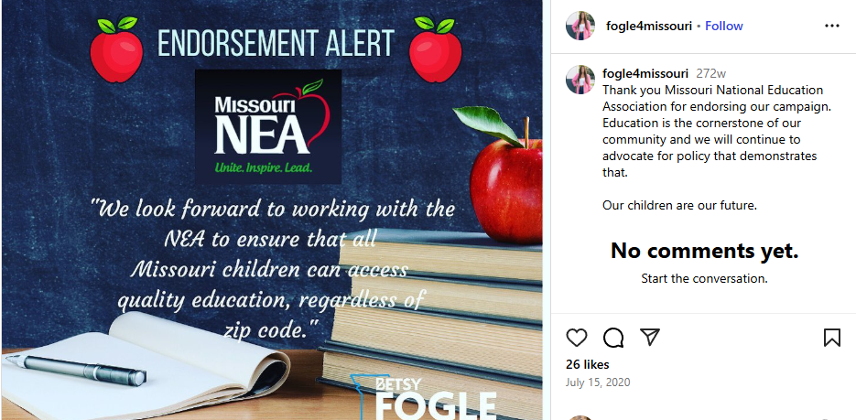
(Betsy Fogle Instagram, 7/15/20)
Fogle Received $500 Form The Missouri National Education Association. (Followthemoney.org, Accessed 9/24/25)

Missouri State Teachers Association
Fogle Has Received 2 Contributions Totaling $1,000.00 From The Missouri State Teachers Association. (Followthemoney.org, Accessed 9/24/25)

Scholarship Program

Fogle Voted Against A Private School Scholarship Program
In March 2021, The House Passed A Bill Providing Scholarships For Students To Attend Private Schools. “The Missouri House of Representatives passed a bill providing scholarships for students to attend private schools. Under the proposal, private donors would donate funds to nonprofits and in turn, receive a tax credit for the full amount of their donation. ‘Creating a small program that would equal less than 1% of the total budget for education at the state level to allow students or families who might not be in a situation that's working for them to apply for a scholarship so that they can do their education a different way, to me, sounds like a reasonable program that, I think, is sorely needed for a lot of families in the state.’ Said Missouri State Treasurer Scott Fitzpatrick. The bill will now move to the senate. ‘I've been a supporter of public education my whole life. My mom is a school teacher and it worked really well for me. There are some students for which that experience is not working,’ said Fitzpatrick.” (Kaitlyn Schumacher, “Missouri's House passes proposal to provide scholarships to private schools,” KYTV, 3/2/21)
- Fogle Voted Against The Bill Saying She Went To Jefferson City To “Fight Anything That Takes Our Public Education Dollars And Puts Them Elsewhere.” “Springfield State Rep. Betsy Fogle voted against the bill. ‘Our teachers do an excellent job in educating our kiddos so I knew when I came to Jefferson City was to fight anything that takes our public education dollars and puts them elsewhere,’ said Fogle.” (Kaitlyn Schumacher, “Missouri's House passes proposal to provide scholarships to private schools,” KYTV, 3/2/21)
- Fogle Said If The Education System Was Fully Funded It Would Alleviate A Lot Of These Problems. “She said there are other ways to help students reach their potential. ‘If we fully funded our public education system and our transportation mechanisms and allowed kiddos to excel in the public school system then a lot of these problems would be alleviated,’ said Fogle. If this bill passes in the Senate, it will only impact areas with a 30,000 population or higher. While this won't make a difference in rural school systems, it will impact the Springfield public school district. ‘We know that the public school systems not only educate our kiddos but we've seen this over the last year, they feed our kids, provide before and after school care to our kiddos we need to be doing everything we can to support that and not take dollars away,’ said Fogle.” (Kaitlyn Schumacher, “Missouri's House passes proposal to provide scholarships to private schools,” KYTV, 3/2/21)
Fogle Said That The State Was Trying To Defund Or Undervalue The Core Of Our Community. “In particular, she has her eyes on fully funding public education - which has been a target of criticism by some Republicans as they sponsored and passed legislation benefiting private and other non-public schools. Republican Gov. Mike Parson signed into law this year a bill that allows parents to receive tax credits from donations to certain education organizations that could offset prices of private schools, a measure Fogle voted against. ‘That's an area that I will always put my foot down is where we're trying to defund or undervalue what I believe is the core of our community,’ Fogle said. ‘It's our students who suffer, and our economy that will suffer in 10 to 20 years.’” (Galen Bacharier, “Rep. Fogle to focus on funding education, child care,” Springfield News-leader, 11/28/21)

Fogle Said She Was Running For State Senate To Fight Proposal’s Like The Scholarship Program
Fogle Said She Is Running For Senate To Continue To Fight Against Proposal’s Like The $50 Million Private School Scholarship Program. “Fogle said she is running to continue fighting to fully fund public schools while opposing efforts to privatize education, in reference to the legislature’s approval of $50 million for a private school scholarship program and attempts, albeit failed, to underfund the K-12 school funding formula. ‘Every child, regardless of ability, regardless of income, regardless of sexual orientation, regardless of anything, this country believes in their future and always has, and I will not allow the majority to continue to underfund and privatize the educational system that all of us hold so dear,’ Fogle said.” (Jack McGee, “Dems optimistic about flipping Springfield’s Senate seat as Betsy Fogle launches campaign,” Springfield Daily Citizen, 6/6/25)
- Fogle Also Said She Is Running To “Close The Wealth Gap.” “Fogle said she is also running to close the wealth gap through ‘sensible tax relief’ and improved access to child care, and keep neighborhoods safe by investing in local law enforcement and mental health and addiction treatment services and invest in labor trades while ensuring students are able to attain a four-year degree without compiling too much debt.” (Jack McGee, “Dems optimistic about flipping Springfield’s Senate seat as Betsy Fogle launches campaign,” Springfield Daily Citizen, 6/6/25)

School Choice
In 2021, Fogle Voted Against HB 349, Expanding School Choice Through The Creation Of The Missouri Empowerment Scholarship Account Program. (HB 349, Passed 82-71, 2/25/21, Fogle Voted No)
- “This bill expands school choice by creating the "Missouri Empowerment Scholarship Accounts Program." The program establishes educational savings accounts (ESAs) that provide eligible parents funding to help send their children to the school of their choice. The program is funded through the issuance of tax credits by educational assistance organizations. ACU supports improving educational outcomes and reducing taxpayer costs by responsibly expanding school choice and supported this bill. The House passed the bill on February 25, 2021 by a vote of 82-71 and the bill was signed into law.” (American Conservative Union, Accessed 9/30/25)
In 2021, Fogle Voted Against HB 137, Ensuring Funding Equality For Charter Schools. (HB 137, Passed 86-66, 4/15/21, Fogle Voted No)
- “This bill advances school choice by enabling charter schools to receive state and local funds in a manner similar to traditional public schools by 2024. ACU supports improving educational outcomes and reducing costs through school choice and ensuring equal treatment for both charter and public schools and supported this bill. The House passed the bill on April 15, 2021 by a vote of 86-66. (The bill failed to advance in the Senate.)” (American Conservative Union, Accessed 9/30/25)
In 2021, Fogle Voted Against SB 86, Prohibiting School Districts From Engaging In Political Electioneering And Expanding School Choice. (SB 86, Passed 84-67, 5/11/21, Fogle Voted No)
- “This House substitute version of this bill would protect taxpayers by ensuring their tax dollars are not used for political purposes and expands school choice opportunities. Under the bill, school districts, their employees, officers, and agents would be prohibited from expending public funds to support or oppose the nomination or election of any candidate, the passage or defeat of any ballot measure, committees supporting or opposing candidates or ballot measures, or to pay off debts or obligations of a candidate or committee incurred for the purposes list above. Additionally, this bill improves educational outcomes for families by expanding public and private school choice. ACU supports protecting taxpayers by ensuring public resources are used for their directly intended purposes, supports improving educational outcomes through school choice and supported this bill. The House passed the bill on May 11, 2021 by a vote of 84-67 and an amended version of the bill was later signed into law.” (American Conservative Union, Accessed 9/30/25)
In 2021, Fogle Voted Against HB 2, Attacking School Choice By Cutting Charter School Funding. (HB 2, Failed 47-104, 3/30/21, Fogle Voted Yea)
- “The Windham (ACUF Lifetime 26%) amendment #5 to the education appropriations bill would target charter schools by striking approximately $5 million from the bill designated for deferred maintenance grants for charter school facilities in operation for more than 10 years. Unlike public schools, charter schools typically only receive state-level funding and receive less per pupil allotments, despite outperforming traditional public schools. ACU supports improving educational outcomes and reducing taxpayer costs by responsibly expanding school choice, not hindering it, and opposed this amendment. The House failed to adopt the amendment on March 30, 2021 by a vote of 47-104.” (American Conservative Union, Accessed 9/30/25)
In 2022, Fogle Voted Against HB 1552 Which Amends The State Charter School Funding Formula. (HB 1552, Passed 103-48, 3/9/22, Fogle Voted No)
In 2023, Fogle Voted Against HB 253 Which Establishes A State School Choice Voucher Program. (HB 253, Passed 85-69, 3/8/23, Fogle Voted No)
In 2024, Fogle Voted Against SB 727 Which Expands The Missouri Empowerment Scholarships Accounts Program. (SB 727, Passed 82-69, 4/18/24, Fogle Voted No)
- Expands The Empowerment Scholarships Accounts Program In The State Of Missouri For Low Income Families With Funding From Private Donors, Who Shall In Turn Receive Various Tax Credits (Sec. A).
- Increases The Cap On Tax Credits From $50 Million To $75 Million Per Year (Sec. A).
- Requires A Local Vote For Approval Of Large-City School Districts To Go To 4-Day Weeks Proposal (Sec. A).
- Specifies That The Provisions Of This Bill Shall Take Effect Immediately Upon Passage And Approval By The Governor (Sec. A). (SB 727, Passed 82-69, 4/18/24, Fogle Voted No)
In 2025, Fogle Voted Against HB 711 Which Establishes Open Enrollment Policies For Missouri Schools. (HB 711, Passed 88-69, 3/12/15, Fogle Voted No)

Parental Bill Of Rights
In 2022, Fogle Voted Against HB 1858, Parental Bill Of Rights. (HB 1858, Passed 85-59, 4/19/22, Fogle Voted No)
- “This bill codifies a parental bill of rights after the defeat of a similarly motivated proposed constitutional amendment. Under the bill, parents would have the right to know what their minor child is being taught in school, the right to know who is teaching their child, and the right to visit the school and receive all school records, among other provisions. CPAC supports strengthening parental rights and supported this bill. The House passed the bill on April 19, 2022 by a vote of 85-59 but the bill was not taken up by the full Senate.” (American Conservative Union, Accessed 9/30/25)
In 2022, Fogle Voted Against HJR 110, Parents Bill Of Rights. (HJR 110, Failed 60-81, 5/9/22, Fogle Voted No)
- “This resolution proposes a state constitutional amendment that codifies a parental Bill of Rights. Among other provisions, it gives parents the right to be notified of any possible criminal offense involving their child and allows them access to their school’s curricula. CPAC supports strengthening parental rights and supported this resolution. The House defeated this resolution on May 9, 2022 by a vote of 60-81.” (American Conservative Union, Accessed 9/30/25)

Voting
In 2021, Fogle Voted Against HB 334 Which Requires Photo ID To Cast A Ballot. (HB 334, Passed 109-46, 2/24/21, Fogle Voted No)
In 2021, Fogle Voted Against HB 738 Which Establishes New Voter ID Laws. (HB 738, Passed 109-48, 3/25/21, Fogle Voted No)
In 2022, Fogle Voted Against HJR 131, Protecting Elections From Non-Citizens. (HJR 131, Passed 97-45, 4/6/22, Fogle Voted No)
- “This resolution proposes a state constitutional amendment that would require a voter to be a United States citizen. The amendment would also require voters to use paper ballots in the voting process that can be preserved for an election audit and would require that voting machines be tested and certified. CPAC supports efforts to preserve ballot integrity and supported this resolution. The House passed the resolution on April 6, 2022 by a vote of 97-45 but the resolution was not taken up by the Senate.” (American Conservative Union, Accessed 9/30/25)
In 2022, Fogle Voted Against HB 1878 Which Authorizes Secretary Of State To Audit List Of Registered Voters. (HB 1878, Passed 97-46, 3/10/22, Fogle Voted No)
In 2022, Fogle Voted Against HJR 94, Requiring An ID To Vote. (HJR 94, Passed 97-36, 3/10/22, Fogle Voted No)
- “This resolution proposes a state constitutional amendment that would require voters to provide election authorities with a government-issued photo ID to vote. Under the amendment, a person without a photo ID could still cast a provisional ballot. CPAC supports reasonable efforts to maintain ballot integrity and supported this resolution. The House passed the resolution on March 10, 2022 by a vote of 97-36 but the resolution was not taken up by the Senate.” (American Conservative Union, Accessed 9/30/25)

LGBTQ
In A 2020 Questionnaire, Fogle Claimed In Missouri LBTQ Community Members Could Be Fired For Identifying As Such, But The Paper Noted That Was Not True. “Fogle: The Missouri Nondiscrimination Act (MONA) has been debated and denied for 20 years. MONA, if passed, would add sexual orientation and gender identity to Missouri's Human Rights Act, which prohibits discrimination in employment, housing, and other public accommodations. Currently, people in Missouri can get fired or evicted from their home for identifying as a member of the LGBTQ community. (Editor's note: LGBTQ individuals can no longer be fired for their sexual orientation or gender identity thanks to a recent U.S. Supreme Court decision, but they can still be evicted or barred from public accommodations.) If elected, I will work to ensure the passage of this legislation and to make sure that legal discrimination does not exist in our state.” (Austin Huguelet, “Meet the candidates for MO House District 135,” Springfield News-Leader, 8/28/20)
In 2020, In A Pride Month Post Fogle Said She Decided To Run For Office Because Of LGBTQ Issues. “As Pride Month comes to a close, our team is so happy to celebrate this endorsement. We can’t wait to be in Jefferson City building a safer, more equitable and more welcoming community. 🌈” (Betsy Fogle Facebook, 6/30/20)
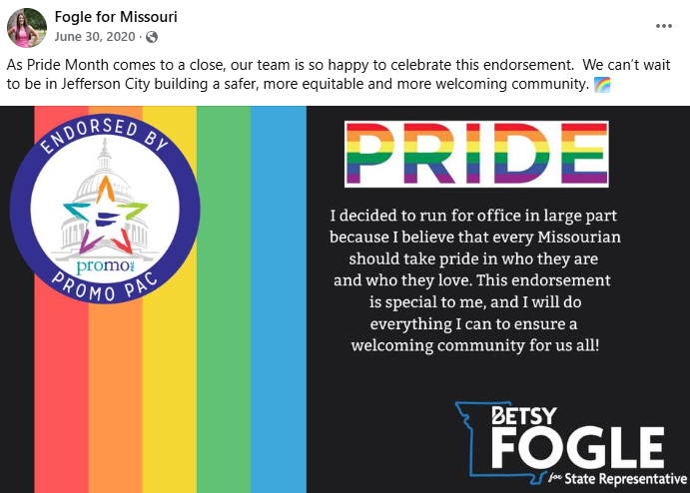
(Betsy Fogle Facebook, 6/30/20)

Transgender

Fogle Has Spoken At Numerous Pro-Trans Events
In 2023, Fogle Spoke At A Transgender Day Of Visibility Event. “The main Transgender Day of Visibility event is Friday, March 31 from 4-8 p.m. at The Barley House at Moon Town Crossing. The event will include art created by local queer artists, live music from musician Athena Kaminksy and various speakers, including District 135 Representative Betsy Fogle and House Minority Leader Crystal Quade.” (Greta Cross, “LGBTQ committee hosts Springfield's first 3-day Transgender Day of Visibility event series,” Springfield News-Leader, 3/25/23)
In 2022, Fogle Spoke At A Pro-Transgender Event Saying It Was Important Those Individuals Have A Voice In The Capital. “The other half of the event space on Sunday was reserved for live music and speakers. Betsy Fogle, Missouri House Representative for District 135, was one of them. ‘We have people, not only across the country but here in Missouri, who have been murdered because of their gender identity,’ Fogle said. ‘All the rhetoric I've seen on the House floor over the last two years, I just think it's incredibly important that individuals facing such hardships have a voice in the capital, and for so long they haven't.’” (Greta Cross, “Following Colorado LGBTQ nightclub shooting, Springfield gathers to remember trans lives,” Springfield News-Leader, 11/21/22)
In 2021, Fogle Posted A Pride Month Post On Facebook Sayin We Need To “Protect Our Transgender Neighbors Now.” “This month and every month, let's work together as Missourians to create a state where everyone receives equal protections and acceptance regardless of gender identity or sexual orientation. #HappyPrideMonth” (Betsy Fogle Facebook, 6/1/21)
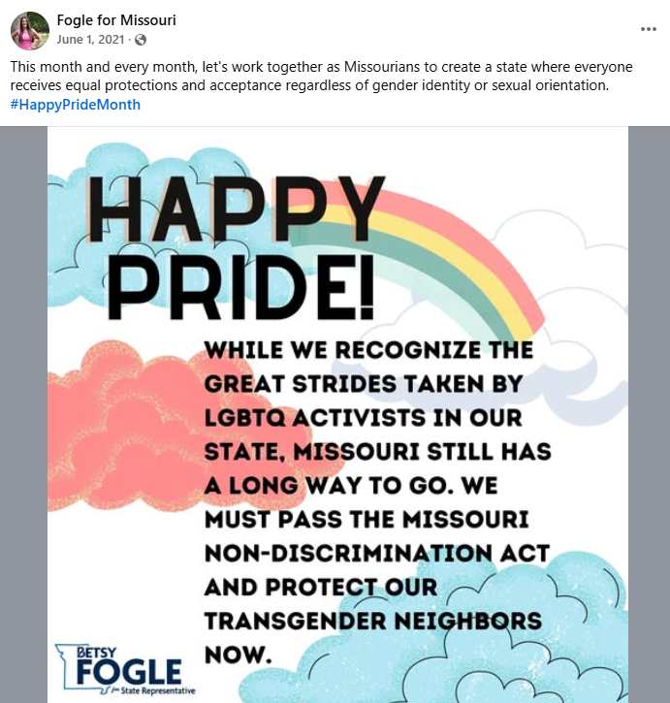
(Betsy Fogle Facebook, 6/1/21)

Fogle Supports Transgender Kids Playing Sport With The Opposite Sex
Fogle Said A Statewide Constitutional Amendment On Banning Transgender Kids From Playing Sports With The Opposite Sex Could “Harm Transgender Children.” “The Legislature has periodically debated constitutional amendments that spark controversy over LGBTQ issues. At the hearing, Rep. Betsy Fogle, D-Springfield, asked why Basye had chosen to propose a constitutional amendment rather than a bill. She argued the increased public controversy that would be provoked by a statewide vote on the issue could harm transgender children.” (Maria Benevento, “Missouri push to bar trans kids from playing sports on teams that match their gender criticized,” St. Louis Post-Dispatch, 3/4/21)
In 2021, Fogle Voted Against HB 1141, Protecting Women’s Athletics From Competition With Men. (HB 1141, Passed 100-51, 4/21/21, Fogle Voted No)
- “The Basye (ACUF Lifetime 83%) amendment #2 protects the institution of women’s athletics by prohibiting males from participating in female interscholastic athletic sports. Under the bill, athletic teams or sports designated for females shall not be open to students of the male sex, but males may participate in sports designed as “coed” or “mixed.” ACU believes all individuals should be treated with dignity and respect and have the same opportunities under the law. ACU also recognizes that there are numerous standard classifications in sports (such as age, weight, etc.) to ensure fair competition. Therefore, ACU supports ensuring fair competition among teams competing across the state and supported this amendment. The House adopted the amendment on April 21, 2021 by a vote of 100-51. (The underlying bill failed to advance out of the House.)” (American Conservative Union, Accessed 9/30/25)
In 2022, Fogle Voted Against HB 1973 Which Prohibits Transgender Girls From Playing On Female Sports Teams. (HB 1973, Passed 98-46, 4/28/22, Fogle Voted No)
In 2023, Fogle Voted Against HB 183 Which Prohibits Transgender Girls From Playing On Female Sports Teams. (HB 183, Passed 104-43, 4/17/23, Fogle Voted No)
In 2023, Fogle Voted Against SB 39 Which Requires Transgender Student Athletes Play Against Those Of Their Biological Sex. (SB 39, Passed 110-49, 5/10/23, Fogle Voted No)
In 2021, Fogle Posted A Photo Of Herself Holding A Sign Saying “Trans Kids Belong” On Instagram. “We are honored to stand with PROMO, ACLU of Missouri and all of the kids and families here in the Capitol today to speak out against #hjr53. Trans kids belong. Period.” (Betsy Fogle Facebook, 3/3/21)
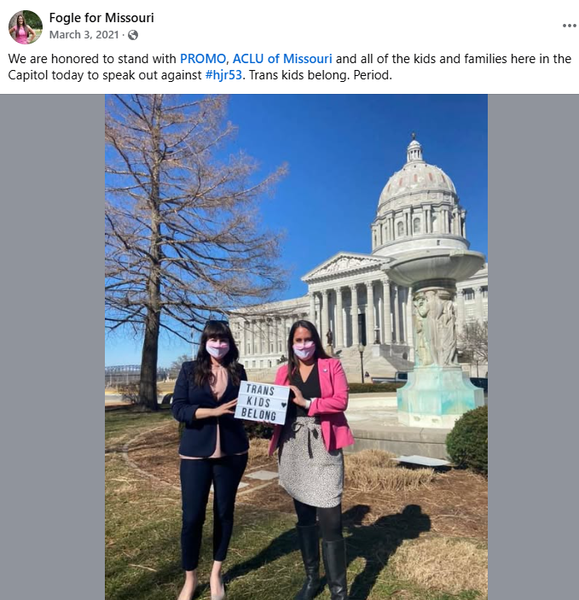
(Betsy Fogle Facebook, 3/3/21)
In 2021, Fogle Posted An Infographic On Instagram Saying “All Students Should Be Able To Participate In The Sports They Love” And Say She Wants To Stop Lawmakers From Keeping Transgender Youth From Participating With The Opposite Sex. “📢 📢 📢 🚨 Our lawmakers are trying to keep transgender youth from participating in sports (AGAIN), and we need your help to stop this attack. This Wednesday at 4:30pm the House Emerging Issues Committee will be hearing HJR53, a bill to ban transgender youth from participating in sports.” (Betsy Fogle Facebook, 3/1/21)
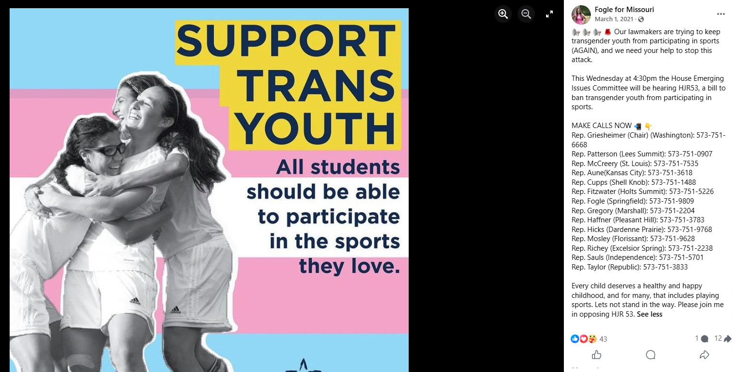
(Betsy Fogle Facebook, 3/1/21)

Fogle Voted Against Prohibiting “Gender-Affirming” Care For Kids
In 2023, Fogle Voted Against SB 49 Which Prohibits Gender-Affirming Medical Care For Minors. (SB 49, Passed 108-50, 5/10/23, Fogle Voted No)

Taxes

During Her First Campaign Fogle Siad She Would Not Pass Tax Hikes
In 2020, Fogle’s Denied She Would Pass Tax Hikes And Defund The Police. “The ads themselves are more or less standard fare, spinning grains of truth into claims that Fogle, a mild-mannered public health worker, is a shameless radical hellbent on booting people off their health care plans, passing a job-killing tax hike, and defunding the police. (Fogle says she will not do any of those things.)” (Austin Huguelet, “GOP attack ads flow into east Springfield House race,” Springfield News-Leader, 10/30/20)

Fogle Said She Would Push For More Online Taxes
Fogle Said She Would Push For Online Taxes “Helms has said he'll give Medicaid expansion a shot despite cost concerns, while Fogle has said she'll ‘guard’ it against Republicans who have discussed refusing to pay for it. And while it's likely she'd take the same votes on school funding and reforms to the criminal justice system, she's said she'll push for more: more funding for early childhood services, more direct confrontation with systemic racism, plus taxes on online purchases to raise revenue and new protections against discrimination for LGBTQ people. ‘I want to live in a community that is inclusive, equitable, and sustainable,’ Fogle said, ‘and our current representation has not led us in that direction.’” (Austin Huguelet, “Fogle, Helms duel in 135th; Dem. candidate confident she can unseat GOP incumbent,” Springfield News-Leader, 9/17/20)

But Fogle Voted For Tax Hikes And Against Tax Decreases
In 2021, Fogle Voted Against HB 649, Reducing Payroll Taxes By Reforming The Unemployment Insurance Program. (HB 649, Passed 101-47, 4/19/21, Fogle Voted No)
- “This bill would reduce payroll taxes by adjusting payouts under the state unemployment program to coincide with the unemployment rate. Under the bill, the duration of unemployment benefits would range between 12 weeks and 20 weeks, with the longest duration of benefits being awarded when the unemployment rate reaches 9%. Additionally, this bill requires the Division of Employment Security (DES) to check rolls on a weekly basis against a list provided by the Missouri Department of Corrections to verify eligibility of benefit claimants. ACU supports reducing hiring costs and expanding employment through this conservative reform to the unemployment system and supported this bill. The House passed the bill on April 19, 2021 by a vote of 101-47. (The bill failed to advance in the Senate.)” (American Conservative Union, Accessed 9/30/25)
In 2021, Fogle Voted Against HB 554, Reducing The Income Tax Rate And Removing Carve Outs To Select Retailers. (HB 544, Passed 96-59, 3/11/21, Fogle Voted No)
- “This bill expands economic growth in Missouri by providing gradual income tax relief. This bill also enacts a five-year phasedown of video service provider fees charged by municipalities, from 5% to 2.5% and prohibits the fee from being imposed on streaming services and satellite companies. To fund these tax reductions, the bill establishes an internet sales tax for remote sellers, thus removing a competitive advantage that was provided to select companies. The bill exempts small out-of-state businesses with annual sales to Missouri of less than $100,000 from collecting the tax due to the administrative costs of compliance. ACU supports reducing tax burdens and applying taxes as broadly as possible to ensure no individual company or industry is provided with a competitive advantage and supported this bill. The House passed the bill on March 11, 2021 by a vote of 96-59. (The bill failed to advance in the Senate.)” (American Conservative Union, Accessed 9/30/25)
In 2021, Fogle Voted For SB 262, Increasing The State Gas Tax By 75%. (SB 262, Passed 104-52, 5/11/21, Fogle Voted Yea)
- “This bill imposes even greater tax burdens on motorists by hiking the state gas tax from 17 cents per gallon to 29.5 cents per gallon by July 2025. While ACU recognizes there are some reasonable justifications to small increases in the gas tax (to make infrastructure improvements or to account for inflation), this bill serves as a new cash grab to avoid reprioritizing spending or eliminating prevailing wage mandates. Additionally, this measure arguably violates the Missouri Constitution by raising revenue higher than permitted levels without voter approval or an emergency declaration. ACU believes the gas tax should only be increased as a measure of last resort to fund core infrastructure, that the state should first seek other cost-saving reforms, and such a large hike should be sent to voters and opposed this bill. The House passed the bill on May 11, 2021 by a vote of 104-52 and the bill was signed into law.” (American Conservative Union, Accessed 9/30/25)
In 2021, Fogle Voted Against SB 262, Requiring Voter Approval To Enact A Proposed Gas Tax Hike. (SB 262, Failed 48-102, 5/11/21, Fogle Voted No)
- “The Chipman (ACUF Lifetime 93%) amendment #1 would provide citizens more input into a proposed 75% gas tax increase by putting the decision up to a vote on the November 2022 ballot. The original bill would increase taxes from 17 cents per gallon to 29.5 cents per gallon after July 2025. ACU believes voters are the most important voice in any fiscal issue, supports maintaining the utmost level of government transparency and fiscal responsibility, opposes driving up gas taxes without first seeking greater efficiency with current resources and supported this amendment. The House failed to adopt the amendment on May 11, 2021 by a vote of 48-102.” (American Conservative Union, Accessed 9/30/25)
In 2023, Fogle Voted Against SB 190 Which Authorizes Counties To Repeal The Property Tax Rates Of Missouri Seniors 65 And Older. (SB 190, Passed 110-45, 5/8/23, Fogle Voted No)
In 2024, Fogle Voted Against HB 2274 Which Establishes Revisions To Corporate Income Taxes. ( HB 2274, Passed 100-50, 4/11/24, Fogle Voted No)
- Specifies That The Income Tax For Corporations Is Equal To 3% Of Missouri Taxable Income (Sec. 1).
- Specifies That After 2026 The Tax Will Be Decreased To 2% (Sec. 1).
- Specifies That All Tax Years Beginning After 2028 There Shall Be No Tax Imposed On The Missouri Taxable Income Of Corporations (Sec. 1).
- Specifies That Nothing In This Section Shall Prevent A Corporate Taxpayer Form Redeeming A Refundable Tax Credit Before The Elimination Of The Corporate Tax Rates (Sec. 1),
In 2025, Fogle Voted Against HB 594 Which Authorizes Income Tax Deduction For Capital Gains. (HB 594, Passed 100-48, 2/13/25, Fogle Voted No)
In 2025, Fogle Voted Against HB 903 Which Reduces Personal Property Tax To 18% Of Market Value Over A 3-Year Period. (HB 903, Passed 84-63, 3/13/25, Fogle Voted No)

Criminal Justice

Fogle Has Called The Justice System Racist
Fogle Said The Criminal Justice System In Missouri Needed To Be Reformed To Increase Funding In Mental Health Access, Education And A Safety Net And Also “Eradicate Institutional Racism Within Our Criminal Justice System.” “Fogle: Calls for changes to the criminal justice system in Missouri are justified. We need to pursue policy that supports the people in our state instead of policy that disenfranchises them. Our current criminal justice system places unfair burdens on both constituents and law enforcement. In Springfield, we have insufficient resources and infrastructure needed to incarcerate the amount of people sentenced. Instead of modeling a reactive approach, Missouri needs to invest in access to mental health services, education, and a strong safety net. In addition, we need to continue to advocate for reforms that eradicate institutional racism within our criminal justice system.” (Austin Huguelet, “Meet the candidates for MO House District 135,” Springfield News-Leader, 8/28/20)
Fogle Said There Is “Inherent Racism Within Our Criminal Justice System.” “‘Out here knocking doors, I've talked to some people interested in this idea of 'changing society,'‘ he said. ‘But most people want to have peace, safety, economic opportunity and maybe some better educational opportunities. They don't want to defund the police.’ (Fogle, for the record, does not appear to want to defund police either, speaking instead of the need to reform policing while ‘fully recognizing the inherent racism within our criminal justice system.’)” (Austin Huguelet, “Fogle, Helms duel in 135th; Dem. candidate confident she can unseat GOP incumbent,” Springfield News-Leader, 9/17/20)

Defunding The Police

Fole Voted Against Bills That Were Intended To Stop Defunding The Police
In 2020, Fogle’s Denied She Would Pass Tax Hikes And Defund The Police. “The ads themselves are more or less standard fare, spinning grains of truth into claims that Fogle, a mild-mannered public health worker, is a shameless radical hellbent on booting people off their health care plans, passing a job-killing tax hike, and defunding the police. (Fogle says she will not do any of those things.)” (Austin Huguelet, “GOP attack ads flow into east Springfield House race,” Springfield News-Leader, 10/30/20)
In 2021, Fogle Voted Against SB 26, Combatting Efforts To “Defund The Police” And Protecting The Due Process Rights Of Law Enforcement Officers. (SB 26, Passed 108-47, 5/14/21, Fogle Voted No)
- “This bill discourages local governments from caving to pressure from far-left radicals in their mission to weaken public safety by defunding the police. Specifically, this bill allows citizens in any community that cuts its law enforcement budget by more than 12 percent to file suit for injunctive relief. Additionally, this bill protects law enforcement officers from frivolous complaints by ensuring due process for peace officers who are the subject of an investigation that could lead to disciplinary action, demotion, dismissal, transfer, or placement that could lead to economic loss. ACU opposes the lawless calls to “defund the police,” supports protecting property rights by ensuring adequate staffing of local law enforcement and supported this bill. The House passed the bill on May 14, 2021 by a vote of 108-47 and the bill was signed into law.” (American Conservative Union, Accessed 9/30/25)
In 2021, Fogle Voted Against SB 26, Combatting Efforts To “Defund The Police” And Protecting The Due Process Rights Of Law Enforcement Officers. (SB 26, Passed 108-47, 5/14/21, Fogle Voted No)
- “This bill discourages local governments from caving to pressure from far-left radicals in their mission to weaken public safety by defunding the police. Specifically, this bill allows citizens in any community that cuts its law enforcement budget by more than 12 percent to file suit for injunctive relief. Additionally, this bill protects law enforcement officers from frivolous complaints by ensuring due process for peace officers who are the subject of an investigation that could lead to disciplinary action, demotion, dismissal, transfer, or placement that could lead to economic loss. ACU opposes the lawless calls to “defund the police,” supports protecting property rights by ensuring adequate staffing of local law enforcement and supported this bill. The House passed the bill on May 14, 2021 by a vote of 108-47 and the bill was signed into law.” (American Conservative Union, Accessed 9/30/25)
In 2022, Fogle Voted Against SJR 38, Preventing Kansas City From Defunding The Police. (SJR 38, Passed 103-44, 5/13/22, Fogle Voted No)
- “This resolution proposes a constitutional amendment that would allow the general assembly to increase the minimum funding threshold for the Kansas City police department. CPAC supports keeping the police department well-funded and supported this bill. The House passed the resolution on May 13, 2022 by a vote of 103-44.” (American Conservative Union, Accessed 9/30/25)

Racial Issues
Fogle Said She Would Push For More Confrontations With Systemic Racism. “Helms has said he'll give Medicaid expansion a shot despite cost concerns, while Fogle has said she'll ‘guard’ it against Republicans who have discussed refusing to pay for it. And while it's likely she'd take the same votes on school funding and reforms to the criminal justice system, she's said she'll push for more: more funding for early childhood services, more direct confrontation with systemic racism, plus taxes on online purchases to raise revenue and new protections against discrimination for LGBTQ people. ‘I want to live in a community that is inclusive, equitable, and sustainable,’ Fogle said, ‘and our current representation has not led us in that direction.’” (Austin Huguelet, “Fogle, Helms duel in 135th; Dem. candidate confident she can unseat GOP incumbent,” Springfield News-Leader, 9/17/20)

DEI
In 2025, Fogle Said That “There Are A Lot Of Us” That Celebrate DEI Policies. “‘The Missouri v. Starbucks case is the crystallization of the litigation risks that companies now face in light of the Trump administration's offensive against what it defines as 'illegal DEI,'‘ said Aaron Goldstein, an attorney at Dorsey & Whitney. On Wednesday, Members of the Missouri House Budget Committee questioned Bailey's decision, making him answer for a lawsuit he filed. ‘I'm just curious if white-served coffee tastes a little bit better because if it does I'm happy to have some,’ said state Rep. Raychel Proudie, a Democrat from Ferguson, according to Missouri Independent. ‘There are a lot of us in this room that celebrate that fact,’ said state Rep. Betsy Fogle, a Democrat from Springfield, at a Tuesday hearing. ‘We want women in the workforce. We want individuals and groups who have historically been out of the workforce to be full participants.’” (Maryam Khanum, “Missouri Attorney General Sues Starbucks for DEI Policy, Claims It Raises Prices and Slows Service,” Latin Times, 2/16/25)
In 2025, Fogle Voted Against HB 742 Which Prohibits State Departments From Spending Money On Diversity, Equity, And Inclusion Initiatives. (HB 742, Passed 108-5, 2/20/25, Fogle Voted No)

Healthcare

Medicaid Expansion

Fogle Is A Big Proponent Of Medicaid Expansion
In 2020, Fogle Wrote An Op-Ed In The Springfield News-Leader Calling For Medicaid Expansion. “Missouri is facing a preventable public health crisis. As the Director of Program Advancement at Jordan Valley Community Health Center, I see the daily impact of poor statewide policy in the faces of our patients. Families are forced to choose between necessary health care or financial insolvency. No one should have to choose between putting food on the table or paying for life-saving medical help for their children. Unfortunately, since lawmakers have refused to pass Medicaid expansion, this is the untenable state of Missouri health care.” (Betsy Fogle, “The indisputable case for Medicaid expansion in Missouri,” Springfield News-Leader, 2/2/20)
- Fogle Called It Unacceptable For Legislators To Vote Against Medicaid Expansion. “Whether passed through our legislature or public ballot measure, around 352,000 additional Missourians would qualify for health insurance following its passage. This would lead to better overall mental, physical and emotional health, as well as a sharp reduction in unnecessary emergency department visits that spike monthly premiums. Additionally, Missouri legislators have voted against Medicaid expansion since 2014, resulting in the third lowest eligibility cap of any state. This is unacceptable. A single parent with two children can't make more than $301 per month in order to qualify for assistance - making it more financially beneficial for parents to avoid entering the workforce, an economic loss for our communities.” (Betsy Fogle, “The indisputable case for Medicaid expansion in Missouri,” Springfield News-Leader, 2/2/20)
- Fogle Noted At The End Of The Op-Ed That She Is Running For State House. “When I knock on doors and talk to voters in my neighborhood, access to affordable and quality health care is consistently the top concern. We know the path forward to reform health care coverage for Missourians, we just need to find the courage to act. Every single day that passes without this important legislation, our families suffer. Join me in the fight to better our community while working toward a healthier Missouri. My name is Betsy Fogle and I am running to represent the 135th House district of Missouri.” (Betsy Fogle, “The indisputable case for Medicaid expansion in Missouri,” Springfield News-Leader, 2/2/20)
In March 2021, Fogle Wrote Another Op-Ed In The Springfield News-Leader Calling For The Expansion Of Medicaid. “I'll never forget the first time I had to look someone in the eye and tell them they couldn't afford to see a doctor. I was working at a community health center and meeting with a single father who worked two part-time jobs at fast food restaurants. He did not have access to health insurance. For years, I saw firsthand the struggles that many of our neighbors faced trying to access medical, dental and behavioral health services. It was those moments that inspired me to run for office. Expanding access to health care for my neighbors became my mission, and I wasn't the only one. In 2020, after years of fierce resistance by Republican lawmakers passing expansion in the legislature, Missourians gathered signatures and utilized their last option - they demanded it go to a vote, and on August 4, 2020, Missourians put Medicaid expansion into our Constitution. With this vote of the people, Missourians pushed back against politicians and demanded action - to bring health care to 250,000 more Missourians and billions of federal dollars into our state.” (Betsy Fogle, “Expand Medicaid to increase health care access,” Springfield News-Leader, 3/18/21)
- Fogle Blamed Republicans For Blocking Medicaid Expansion. “In the last few weeks, your GOP lawmakers have done the exact opposite of what we told them to do. Instead of working together to make the July 1 deadline for Medicaid expansion, they have filed legislation that would make it harder for our neighbors to access health care. Instead of helping our constituents know how to enroll for benefits, they have tried to find ways not to fund it. They are even attacking the very process that Missourians used to get this legislation passed - trying to make it harder for Missourians to put things on the ballot. Failing to expand Medicaid would not only deny health care to hundreds of thousands of Missourians and force our economy to lose out on billions of dollars, it would be a direct attack on the democratic process. Missourians did their job to expand Medicaid, now it is time for your lawmakers to do the same.” (Betsy Fogle, “Expand Medicaid to increase health care access,” Springfield News-Leader, 3/18/21)

Other Issues
In 2025, Fogle Voted Against HB 595 Which Prohibits Local Governments From Requiring Landlords To Accept Section 8 Vouchers. (HB 595, Passed 103-37, 5/5/25, Fogle Voted No)
Fogle Claimed A “Well-Known Leader In Springfield” Once Told Her “The World Was So Much Better When Women Didn't Have Notions Of Running For Office Or Working Outside Of The Home.” “State Representative Betsy Fogle noted she had been told by somehow who ‘a decade ago was a well-known leader in Springfield’ that ‘the world was so much better when women didn't have notions of running for office or working outside of the home.’ ‘While we would hope these sentiments have disappeared, in a lot of places they haven't,’ Fogle said.” (Andrew Sullender, “Misogyny and double standards - bipartisan panel encourages women to run despite challenges,” Springfield News-leader, 9/13/22)

2nd Amendment
In 2021, Fogle Voted Against HB 85 Which Prohibits Enforcement Of Federal Gun Laws. (HB 85, Passed 103-43, 2/2/21, Fogle Voted No)
In 2021, Fogle Voted Against HB 52 Which Establishes That Those With Concealed Carry Permits May Bring Their Guns On Public Transportation. (HB 52, Passed 124-32, 3/8/21, Fogle Voted No)
In 2022, Fogle Voted Against HB 1462, Expanding Gun Rights. (HB 1462, Passed 101-40, 3/9/22, Fogle Voted No)
- “This bill removes a prohibition that restricts the carrying of legal firearms while in areas of public transportation, churches, and other places of worship by concealed carry permit holders. CPAC supports the founders’ belief in the Second Amendment and supported this bill. The House passed the bill on March 9, 2022 by a vote of 101-40 but the bill was not taken up by the Senate.” (American Conservative Union, Accessed 9/30/25)
In 2023, Fogle Voted Against HB 282, Various Measures To Improve Missourians’ Second Amendment Freedoms. (HB 282, Passed 105-41, 4/17/23, Fogle Voted No)
- “This bill lowers the age at which an individual may be issued a concealed carry permit by one year. It also removes a prohibition that prevented permitholders from carrying a concealed firearm into a place of worship. CPAC supports the founders’ belief in the Second Amendment and supported this bill. The House passed this bill on April 17, 2023 by a vote of 105-41 but the bill stalled in the Senate.” (American Conservative Union, Accessed 9/30/25)
In 2025, Fogle Voted Against HB 1175 Which Establishes The Second Amendment Preservation Act. (HB 1175, Passed 100-51, 3/27/25, Fogle Voted No)

Abortion
In 2020, Fogle Was Endorsed By EMILY’s List. “WASHINGTON, D.C. Today, EMILYs List, the nations largest resource for women in politics, congratulated 15 women on advancing to the general election for the Missouri General Assembly and statewide offices. Stephanie Schriock, president of EMILYs List, released the following statement: EMILYs List is thrilled to congratulate these women leaders on advancing to the general election. We are proud to stand with trailblazing candidates on the statewide and legislative level who are fighting to ensure that pro-choice Democratic women have a seat at the table in Jefferson City. These women will push for a more transparent government that values Missourians health and safety. Once elected and reelected, they will continue to fight for progress and we look forward to helping them cross the finish line in November.” (EMILY’s List, “EMILY'S LIST STATEMENT ON MISSOURI'S LEGISLATIVE AND DOWN-BALLOT STATEWIDE PRIMARY ELECTION RESULTS,” Press Release, 8/5/20)
In 2021, Fogle Voted For HB 10, Directing Taxpayer Funds To The Abortion Industry And Planned Parenthood. (HB10, Failed 44-105, 3/30/21, Fogle Voted Yea)
- “The Unsicker (ACUF Lifetime 24%) amendment #6 to the health-services appropriations bill would permit taxpayer funds to be used to take the lives of the unborn through abortion. Specifically, the bill strikes a portion of a rider for family planning, thus allowing state funds to be used for abortion or be directed to abortion providers such as Planned Parenthood. ACU believes abortion is a human tragedy, supports restrictions on the practice, and opposed this amendment. The House failed to adopt the amendment on March 30, 2021 by a vote of 44-105.” (American Conservative Union, Accessed 9/30/25)
In 2022, Fogle Voted Against HB 2012 Which Establishes Protections For "Infants Born Alive.” (HB 2012, Passed 91-37, 4/6/22, Fogle Voted No)
In 2022, Fogle Said She Met A Pregnant 11-Year-Old Who Was Raped By Her Uncle. “Abortion is now illegal in Missouri. No exceptions for rape or incest. Right before I was elected, I met a pregnant 11 year old who has been raped by her uncle. What about HER rights? Betsy Fogle (@Fogle4MO) June 24, 2022” (Marina Silva, “Missouri leaders, organizations react to overturning of Roe v. Wade,” KYTV, 6/25/22)

Religion

Fogle Has Voted Against Religious Freedom
In 2022, Fogle Voted Against HB 1724, Religious Freedom On Campus. (HB 1724, Passed 95-36, 3/10/22, Fogle Voted No)
- “This bill prohibits public institutions of higher learning from discriminating against a belief-based student association based on its requirement that leaders of the association adhere to its sincerely held beliefs, sincere practice requirements, and standards of conduct. CPAC believes it is vital to the preservation of First Amendment freedoms that on-campus belief-based organizations not be discriminated against and supported this bill. The House passed the bill on March 10, 2022 by a vote of 95-36 but the bill was not taken up by the full Senate.” (American Conservative Union, Accessed 9/30/25)
In 2023, Fogle Voted Against SB 34 Which Authorizes Schools To Offer Elective Courses On The Bible. (SB 34, Passed 99-45, 5/12/23, Fogle Voted No)
In 2024, Fogle Voted Against HB 1518 Which Prohibits Higher Education Institutions From Discriminating Against Religious Student Associations. (HB1518, Passed 100-46, 3/7/24, Fogle Voted No)
In 2025, Fogle Voted Against HB 75 Which Prohibits Any Public Official From Restricting Access To Places Of Worship. (HB 75, Passed 106-38, 2/13/25, Fogle Voted No)

COVID

Fogle Said She Would Have Pushed Harsher COVID Requirements
Fogle Criticized The Governor And Others For “Acting Like Masking Is An Option.” “Fogle: There has been a demonstrated lack of leadership from Missouri's elected officials. Between our governor refusing to issue state-wide mandates and the Republican-led legislature not taking this crisis seriously, the lack of response has put immense pressure on local leaders to handle the crisis on their own. We are fighting against inconsistent messaging and that struggle becomes more difficult when we are fighting our own leadership. Missouri's response to the COVID-19 epidemic has left many people feeling helpless. From the beginning, the lessons learned in places where the outbreak peaked were ignored. Masks, while inconvenient, save lives. Our governor and other leaders continue to travel around our state endangering our neighbors by acting like masking is an option. I am thankful for local leadership, including our health department and our local hospital officials, who stepped up to navigate uncharted territory over the last five months.” (Austin Huguelet, “Meet the candidates for MO House District 135,” Springfield News-Leader, 8/28/20)
Fogle Said She Would Have Pushed For Faster Stay At Home Orders And Mask Mandates For The COVID Pandemic. “While Helms has said he's largely satisfied with the state's hands-off coronavirus response, Fogle says she would have pushed for faster action on stay-at-home and masking mandates.” (Austin Huguelet, “Fogle, Helms duel in 135th; Dem. candidate confident she can unseat GOP incumbent,” Springfield News-Leader, 9/17/20)
In 2021, Fogle Voted Against HB 75 Which Requires City Council Approval Of Extended Business Closures. (HB 75, Passed 108-47, 3/11/21, Fogle Voted No)
In 2021, Fogle Voted Against SB 51 Which Establishes Protections For Various Organizations From COVID-19 Related Lawsuits. (SB 51, Passed 97-57, 5/14/21, Fogle Voted No)

Court Packing
In 2021, Fogle Voted Against SCR 6 Which Establishes Disapproval Of SCOTUS Expansion. (SCR 6, Passed 103-30, 5/13/21, Fogle Voted No)

Environment
Fogle Denied That She Would Support The Green New Deal. “One ad, for example, suggests she would support the Green New Deal because she was endorsed by the Missouri Sierra Club, whose national parent organization supports the plan to power all transportation and generate all electricity with renewable energy by 2030. ‘But those things aren't even applicable to a state representative race in Missouri,’ Fogle said. ‘That's federal legislation.’ ‘I do support the environment, clean jobs and renewable energy, and I think the people in my district do, too. But I'm not voting on the Green New Deal.’” (Austin Huguelet, “GOP attack ads flow into east Springfield House race,” Springfield News-Leader, 10/30/20)

Free Speech
In 2023, Fogle Voted Against HB 136, Protecting First Amendment Freedoms At Missouri’s Universities. (HB 136, Passed 108-42, 4/11/23, Fogle Voted No)
- “This bill prohibits public universities from taking adverse actions against belief-based student organizations because of their beliefs or because of requirements in place within the organization stating that its leader must be an adherent to their beliefs. CPAC supports efforts to protect First Amendment freedoms on college campuses and supported this bill. The House passed this bill on April 11, 2023 by a vote of 108-42 but the bill did not progress in the Senate.” (American Conservative Union, Accessed 9/30/25)

Medicare For All
On Medicare For All Fogle Said “I Want More People To Have Coverage, Period, Whether That's Public Or Private.” “She said the same thing about suggestions she would support a ‘Medicare for All’ plan nixing private insurance. ‘I want more people to have coverage, period, whether that's public or private,’ she said.” (Austin Huguelet, “GOP attack ads flow into east Springfield House race,” Springfield News-Leader, 10/30/20)

Border
Fogle Criticized Spending To Send Troops To The Southern Border. “‘Whether or not you like the bill, in my mind, is not the question we're asking today,’ Rep. Betsy Fogle, D-Springfield, said. ‘The question we're asking today is: do we want to give an additional $2 million knowing that the troops are already going to go in case of another crisis like a tornado or some other natural disaster hits our state?’” (Emily Manley, “Missouri House gives initial approval for $2.2M to send troops to southern border,” KTVI, 3/5/24)

Media Bias
While In High School, Fogle Said “I Think The Media Is Really Biased.” “Yet, to Kristin Ray, 17, a class is not necessary to know about government. She said she is continually reminded of facts when she watches television newscasts. Classmate Betsy Fogle, 16, disagrees. ‘I think the media is really biased,’ Fogle said, adding that people shouldn't form their opinions based on what others say. ‘You don't want to go around the world doing what your friends do. You want to be educated.’” (Melissa DeLoach, “A lesson on civic duty,” Springfield News—Leader, 9/18/06)

